Unit Testing with REST Client, Fire fox plug -in

Fetching shop details with id

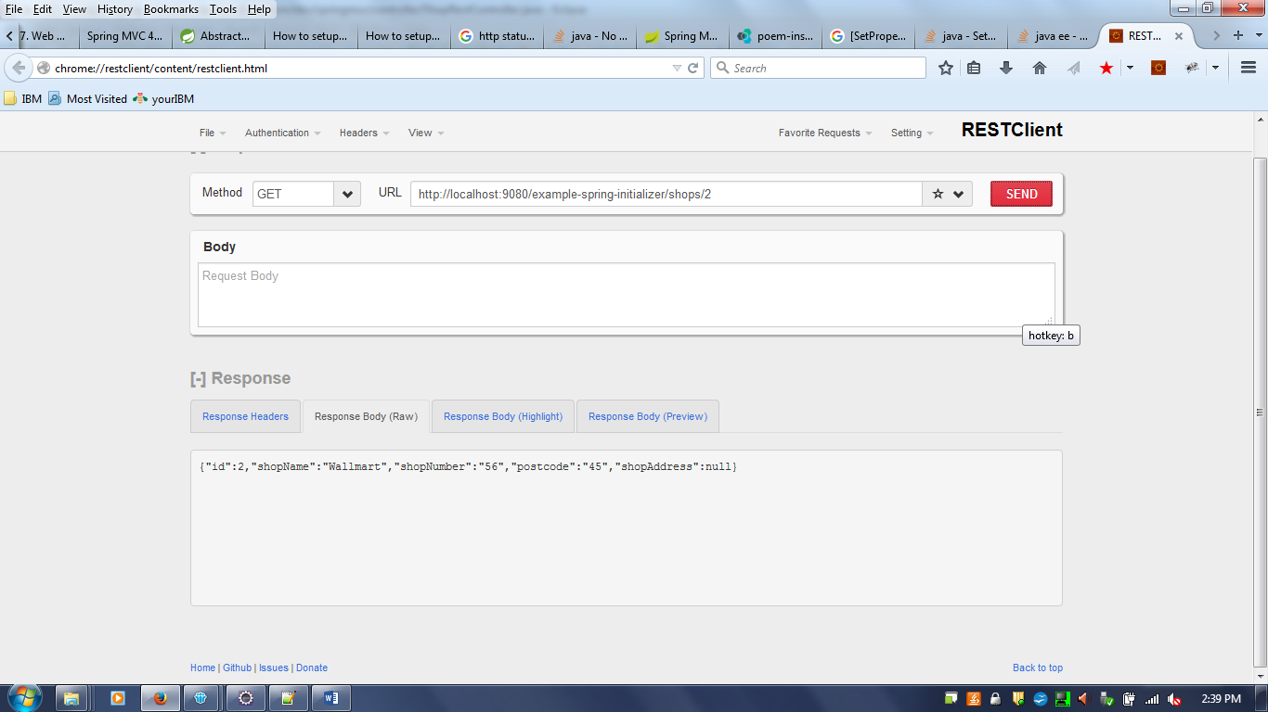

Get all the shops

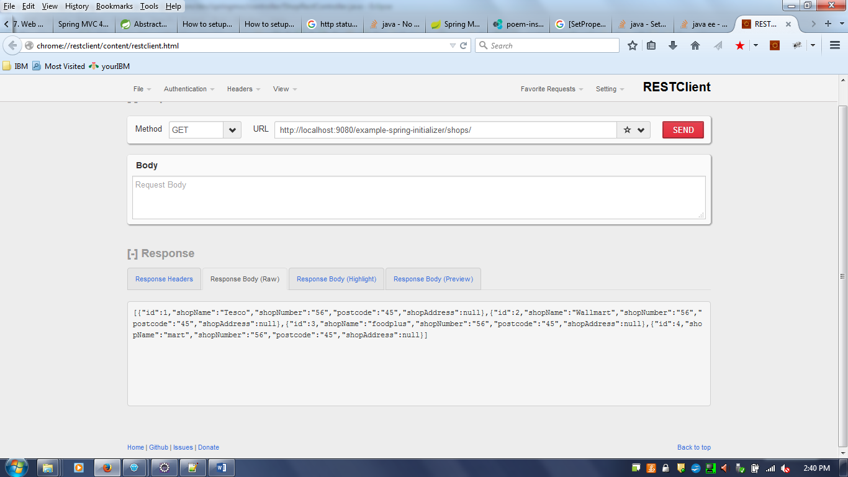

Fetch with Latitude and Longitude updated calling Google API
Get by Id includes lat and long

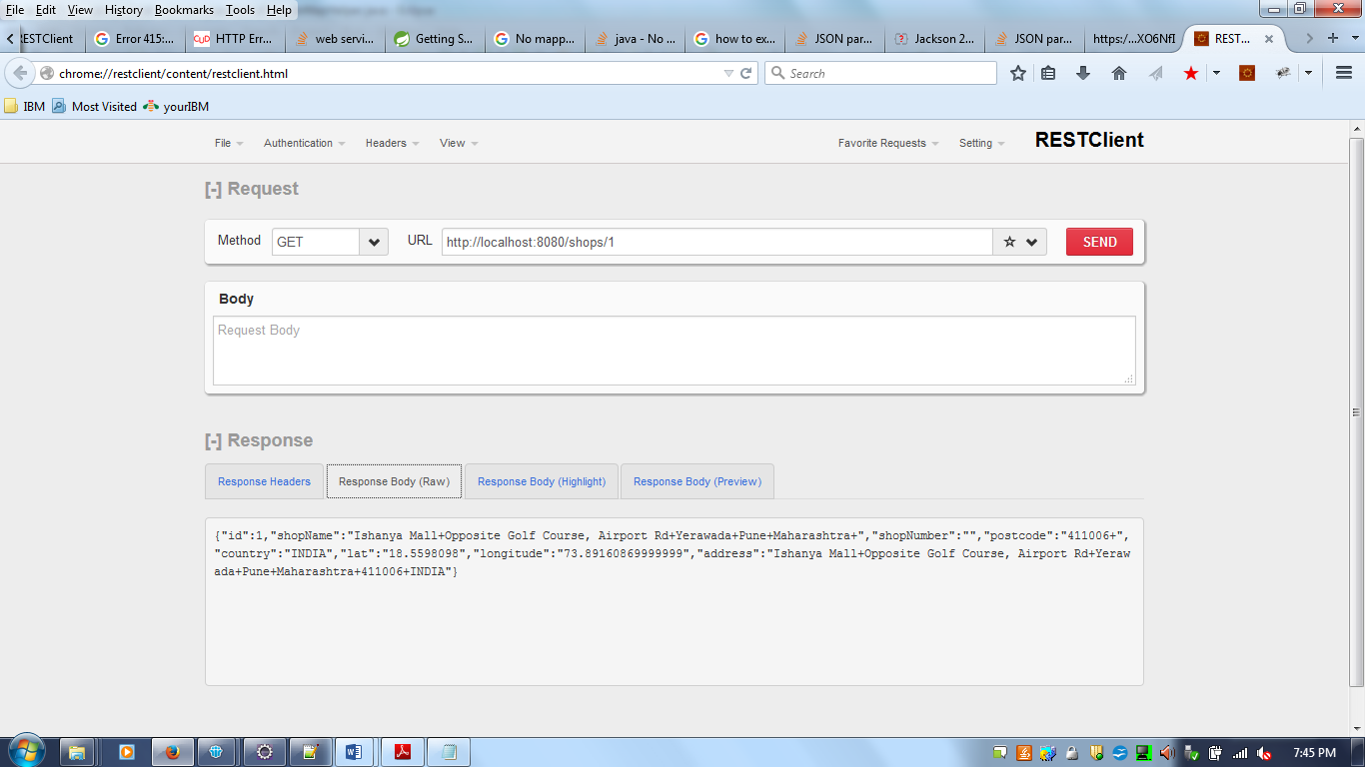
Fig -2 – Get by Id includes Lat and Long

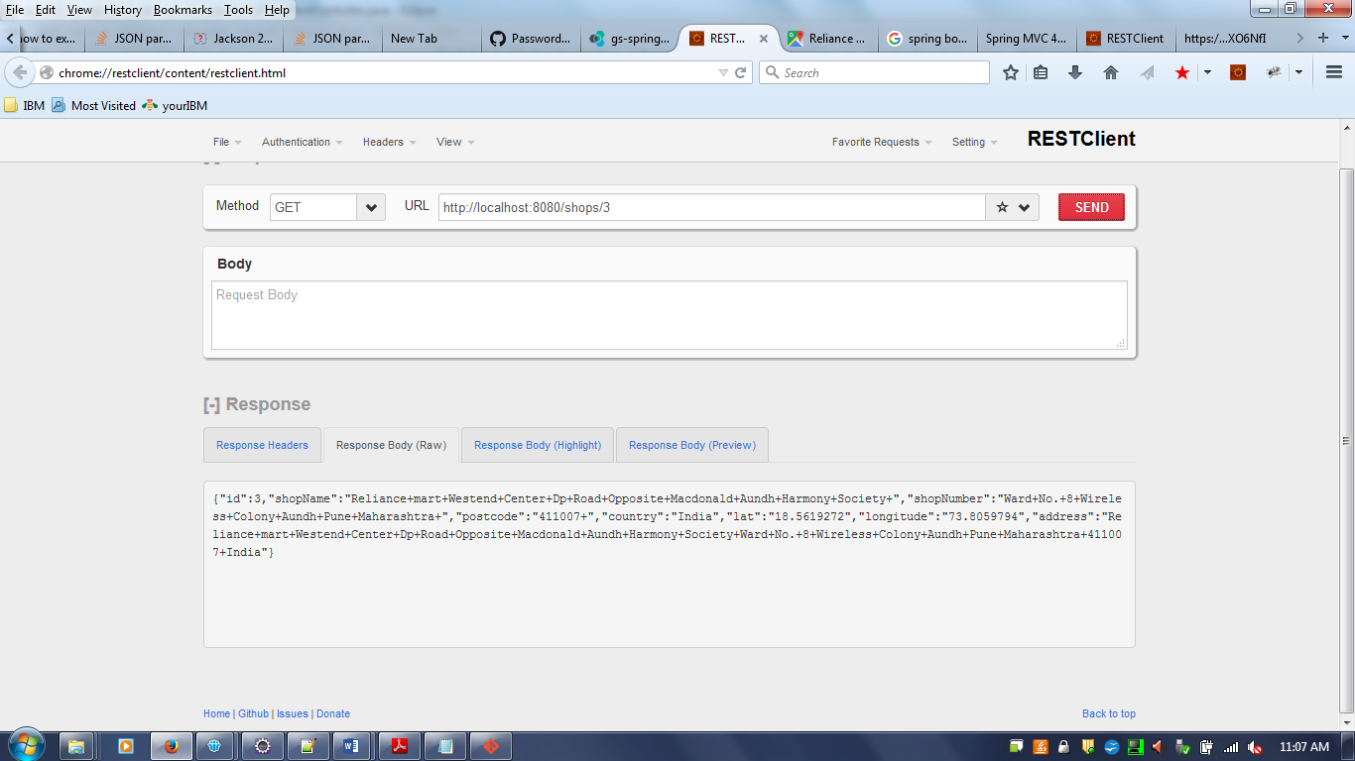

Fig -3 – Deleted By Id, Snapshot encosed below

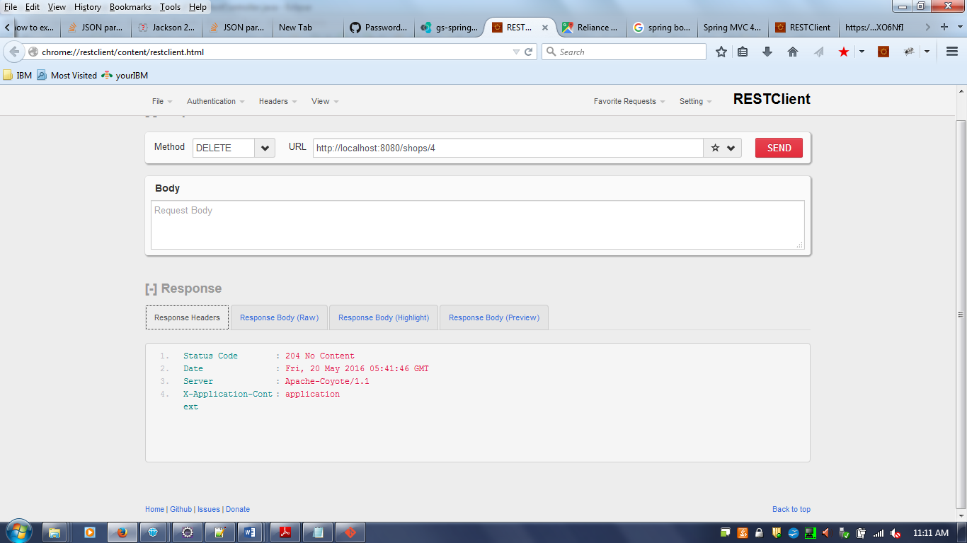

Fig -4: POST operation shown below, for the intitial post , lat and long is null, gets updated while GET operation if the address passed is correct.

